Welcome to
ELOI MINISTRIES
& ELOI House
Volunteer/ Intern Welcome Pack
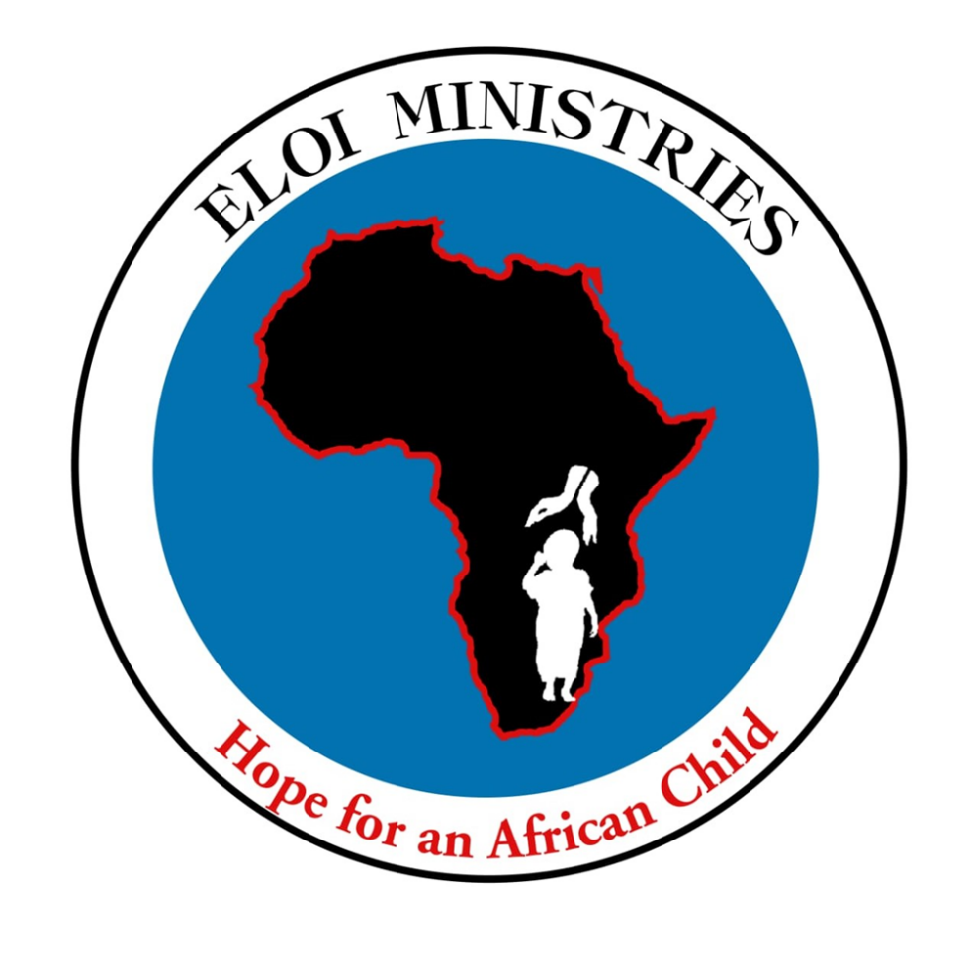


Dear Volunteer/ Intern,

Welcome to ELOI Ministries Uganda.
Being a charity, ELOIM is highly dependent on the efforts of volunteers. Therefore we are most grateful that you have decided to put your talents, passion and commitment to the benefit of ELOIM. Not for the glory of ELOIM but as a gift to our beneficiaries – people in the communities we serve for whatever reason.
As our obligation to them and to you, we have prepared this Volunteer Welcome Pack to make your stay as fruitful as possible and to make it a pleasant one at the same time. You’ll find information to help prepare you for your trip as well as practical information for your stay at ELOI House. In case this is not the first time you are volunteering with us, welcome back!
We at ELOIM do our best to further develop and improve our set up; should you have any suggestions or advise; we are more than willing to consider them.

Have a good time!

Tendo Steven.
President/ Executive Director

ELOIM Mission & Objectives
Our mission:
“To bring dignity & hope for men, women & children in African Communities through Healthcare, access to justice, Education and community re-integration”
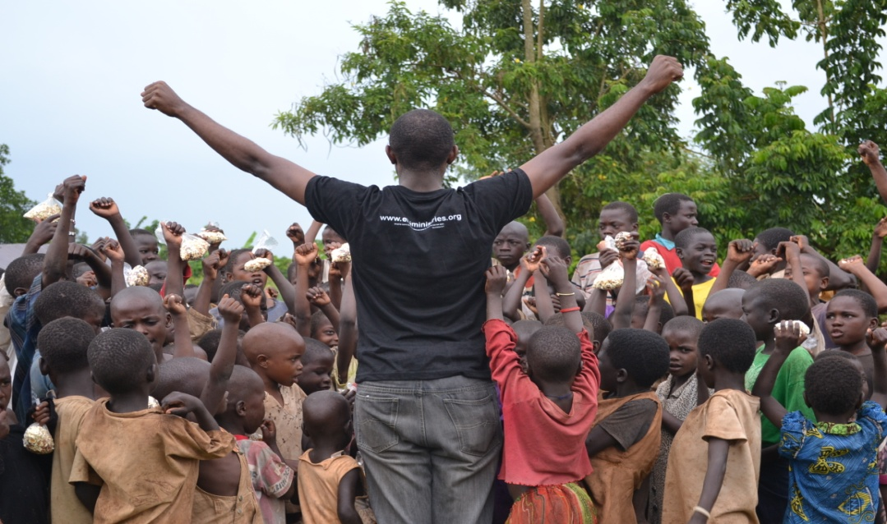
Our Major Objectives: We are working in four main areas;
Education- fighting illiteracy, restoring self-esteem and equipping people in poor Communities with informal and formal education and vocational, creative training.

Healthcare - providing preventative, curative and palliative healthcare to poor communities from birth to death.

Justice - equipping people in poor communities, lawyers and the judiciary with legal knowledge as well as providing legal and paralegal services.

Community Reintegration/ Rehabilitation - breaking the cycle of crime, continuing rehabilitation and reintegration and giving hope and dignity to poor people & their families for both improved and harmonious living.

For more information, please ask for the latest version of our Management Guidelines or log on to our website at www.eloiministries.org

Preparing for your trip to Uganda
We know there can be a lot to think about prior to travelling on any trip so we’ve prepared this checklist to help make things easier!
The timings are a guideline, so don’t panic if you’ve arranged your visit at shorter notice – however you may need to keep a much closer eye on getting things done! It’s not an exhaustive list but should ensure that you’ve organized the basics and prevent last minute problems!
When | Activity | Information | Complete
On receipt of this pack – | Visitor Info Sheet & Disclaimer | Please return the Visitor Information Sheet & Disclaimer (if not sent with application) to us at volunteer@eloiministries.org and copy in steven.tendo@eloiministries.org
12 weeks + before departure | Flight bookings & accommodation  Immigration requirements | ELOIM receives discounted flights with Rwanda Airways. If however, you prefer to make your own travel arrangements, please let us know as soon as possible (i.e. flight times, flight number, dates of arrival etc.)  We also have our own lodgings at the ELOI House which may be available. Our administrator in Uganda -Scovia Agaro- scovia.agaro@eloiministries.org can look into these for you. Please contact us if you require accommodation at this point so we can ensure there will be room for you. Please Note: Copy in steven.tendo@eloiministries.org regarding all correspondence regarding your accommodation, flights and airport transfers.  You are obliged to ensure that you meet the relevant immigration requirements, which may include having a work permit, and that this should be clarified with the Ugandan High Commission before purchasing flights.  Make sure that you include the dates in your VISA application so that the right number of days is processed. For example, instead of saying a two months VISA, state the dates of the visa requirement i.e. 01st Sept 2022 to the 30 Oct 2022.
8 – 12 weeks prior to departure | Tour and Travel arrangements | In case you have to take a tour anywhere in Uganda as an ELOIM volunteer, we have to arrange for this well in advance. Please email a readable copy of your passport & up to date small face photo to Scovia Agaro, on the email above.
6 – 8 weeks prior to departure | Vaccinations | Prior to leaving for Uganda it is vital that you consult your GP, Nurse or Travel Clinic to check which vaccinations you need to have (if appropriate inform them that you are working in a remote poverty stricken environment).  You can get some vaccinations free on the NHS – try here first as the cost can mount up!  Some vaccinations require weeks to build your immunity therefore you should get this booked ideally six weeks in advance (or a few months more if you have not been vaccinated for Hepatitis).
6 weeks prior to departure | Objectives | Please confirm the objectives and plan for your visit with your ELOIM contact
3 – 4 weeks prior to departure | Visa | It is possible to buy a 3 month visa at Entebbe Airport when you land for around 50 USD; however it can give peace of mind to have organized this in advance.  You can do this at the Uganda High Commission on Trafalgar Square in London. Opening hours are 10.00 – 13.00 Mon – Fri (excluding UK or Ugandan bank holidays).  OR  The Embassy of the Republic of Uganda is located on the address below:  5911 16th Street NW,  Washington, DC 20011  Phone: +1-(202) 726-7100  Fax: (202) 726-1727  Email: washington@mofa.go.ug; info@ugandaembassyus.org; ambauganda@aol.com  Office Hours:  Monday - Friday - 9:00am to 4:00pm (EST)  Consular Hours:  Monday - Friday - 9:30am to 3:00pm (EST)  Normal processing time is 48 hours so you will need to visit twice. Other options include following their website for details of how to do this remotely or using a passport company who take it for you.
Accommodation, Flight, and Airport Transfer Payment
 | STUDENTS | It costs $600(USD) per month to stay in the ELOI House or  $150(USD) Per week.
 | WORKERS/ CORPORATES | It costs $700(USD) per month to stay in the ELOI House or  $175(USD) Per week.
 | RETIREDS | It costs $800(USD) per month to stay in the ELOI House or  $200(USD) Per week.
 | NOTE: | Before you depart, we ask that your accommodation, flights (if ELOIM has booked for you) and airport transfers (if required) have been paid in full.  All the above prices Include all meals, accommodation, internet, transport fares from the airport on arrival and back to the airport on departure. A trip to any tourist site in Uganda can be arranged at a cost, kindly inform us in advance.
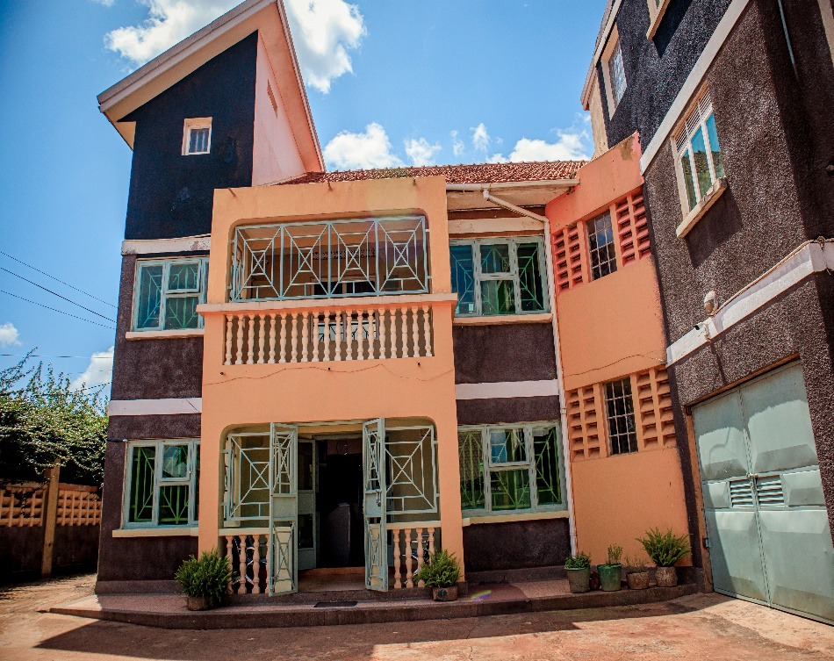  2 weeks prior to departure | Accommodation, Flight and Airport Transfer Payment | THE ELOI HOUSE FOR VOLUNTEER ACCOMODATION
 | Accommodation, Flight and Airport Transfer Payment | 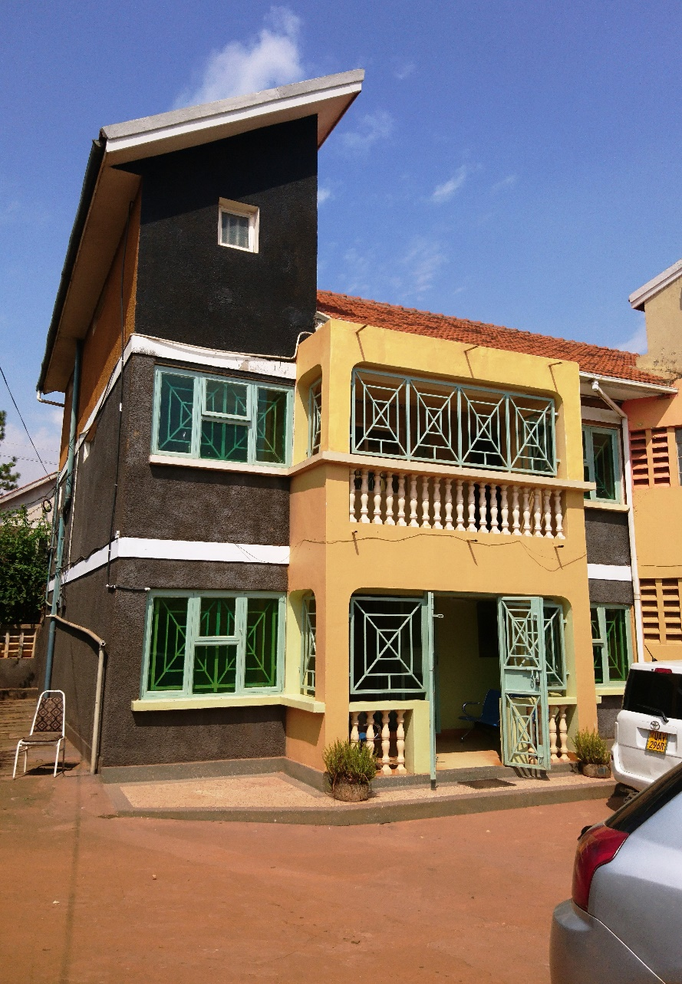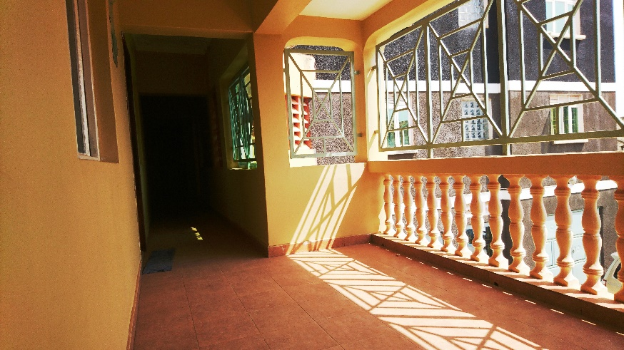  It takes around 1 hour for the taxi journey from Entebbe to Kampala. Contact Scovia to help you with this if you prefer using public means or special hire.  You can make payment to ELOIM for all of the above via BACS or by cheque. ELOIM will invoice you for all of the above, but please confirm when payment has been made by emailing steven.tendo@eloiministries.org .
Ad hoc before departure | Buying key items | The following items may be useful for your trip: umbrella, lightweight raincoat, proper shoes (for the rainy season), anti-insect spray, suit &shirts / ties to last your stay, torch, surge protector (Uganda uses British sockets however, electricity flow may vary) and ear plugs (sometimes the dogs bark early!) Also for the ladies include a dress or smart casual outfit. In most cases people do get the odd evening to socialize.
Ad hoc before departure | Buying Currency | Uganda’s currency is Shillings (UGX)  $1 = 3,823.38 UGX  Note that airport bureaus rarely keep UGX so it’s best to organize these in advance. Entebbe airport has a cash point and there are banks in Kampala including ABSA Bank however they may only allow certain brand bank cards.
At the airport | SIM Card | A local SIM card can be obtained very cheaply at the airport (around 20,000 UGX including airtime). This will be cheaper than using an overseas mobile and will also allow easier communication with Ugandan mobiles – worth buying one! The country code for Uganda is +256 or 000 256.  You can carry your own phone as long as it is unlocked to work on any network it would work in Uganda. Or you can load your airtime on our office phones and call anywhere you want.

On arrival
Entebbe International Airport
The airport is small however is clean and well maintained.
In much the same way as any airport be prepared to queue for some time to pass through passport control. It’s worth being last on to the transporting bus from the plane to be first off at the doors to the airport!
Your luggage will arrive on the baggage carousel where there are trolleys available. A small shop is also located here. You’ll then enter the arrivals hall which is minutes from the car park.
If your flight arrives or departs after dark it is worth having mosquito spray to hand – the airport is on the side of Lake Victoria and attracts a number of these insects!
Local tips!
Greeting people – Ugandan’s like to take their time with greetings. Don’t be surprised when shaking their hand if they hold it for a length of time (even if both are men) – this is perfectly normal and can look rude if you pull your hand away quickly.
Be prepared to be asked how you are and several other polite questions – it is normal to reciprocate these. Ask questions such as:
- How are you?
- How is your day?
- How is your family?
Transport – Local transport in Kampala can be differentiated into three categories:
- Boda bodas ( safe boda, uber boda) – small motorbikes for one or two passengers. Helmets should always be worn! These are a quick way of getting about but account for many hospital cases and are known to be dangerous in busier areas as they duck between cars etc. at speed. Ask the rider to drive safely and agree a price before you set off. The office team can advise you of what price seems reasonable. We advise to avoid them as much as possible unless its really inevitable.

- Matatu – mini bus for 18 passengers. Just halt them on the side of the road. They are cheap (under 6000 UGX) and bring you conveniently into Kampala City Centre and other destinations. Just try them to get the experience of public transport in Kampala! However we advise company of one of our local staff.

- Special Hire – our administrator can arrange a taxi for you. Negotiate a price in advance. Be careful when travelling after dark – a special hire is the best option or our (ELOIM) vans but at a cost (300,000 UGX).
ELOI MINISTRIES’ VANS & CARS.
ELOIM has vans some of which are shown in pictures below that are used to transport volunteers to the different project grounds around the Nation. In case of any emergency, we have small standby cars ready to rush any injured volunteer to the hospital.
Those who want to tour a round Uganda, these vehicles can be used at a fee and a tour guide may be provided depending on where and when.
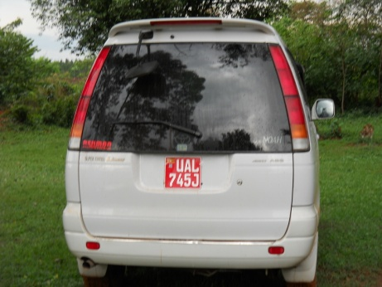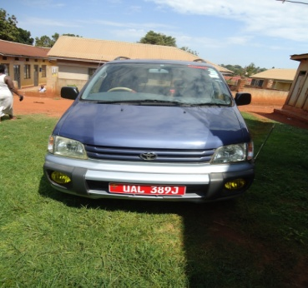
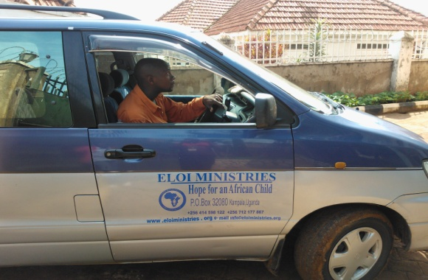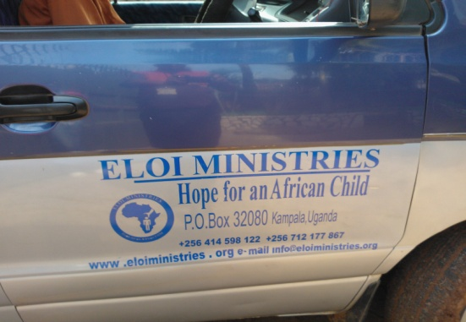
Our location
- ELOIM is located in the vicinity of Kampala, the capital city of Uganda. The area is called kiwatule near St Mbaaga Tuzinde Catholic Church and situated few kilometers from the city center which is better known.
- The journey from Entebbe to Kiwatule takes about 52mins (51.8km) via the Entebbe express way.
- However, when you reach Kampala city center, you can call us on our Hotlines which are on 24/7. +256200908342, +256414688342-office, +256 750420394-Mobile.
ELOI Houses
- For those staying in ELOI Houses, the residence has simple facilities in the form of two twin and one single room, a shower, dining room, a large quiet and comfortable living/ TV/ Board room and three balconies (with a great view!).
- ELOI house has wireless internet, a library which you may use, and IT center (in case you don't have a laptop), mosquito nets, fans, ample storage in the rooms and a work desk.
- Our friendly housekeeping staff will keep your room clean and can do some washing and ironing for you. They will also prepare a joint breakfast and dinner.
- Please give any valuables to (Admin) to store for safe keeping.
- Your security is protected by a 24 hour guard – please inform them if you will be out very late. The garden is also the living area as well as for parking.
- Be advised that ELOI Houses are strictly non-smoking area though smokers are welcome to do so on the balconies or other outdoor areas.
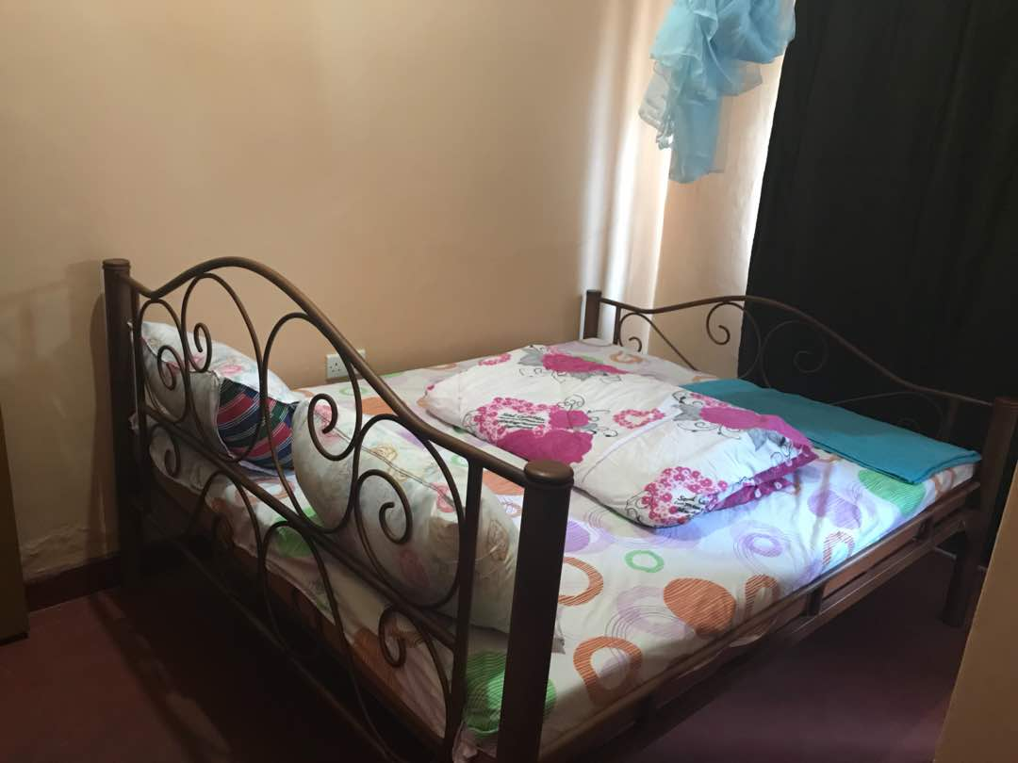
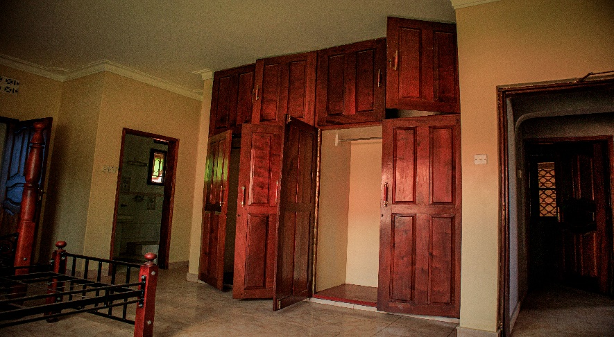

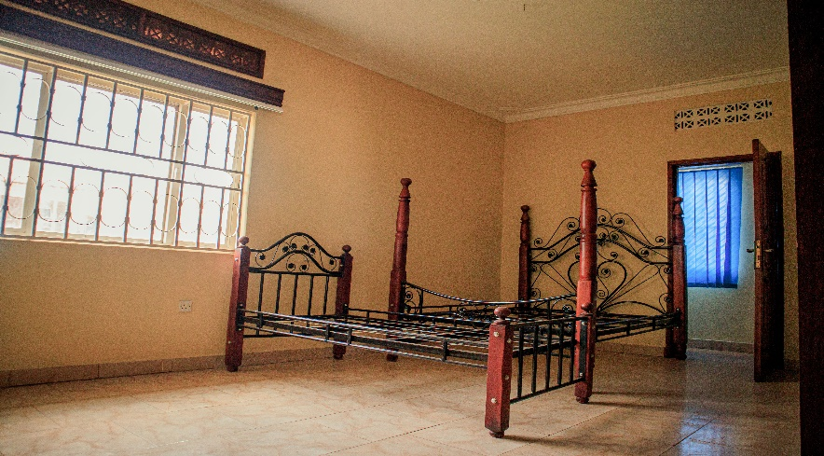
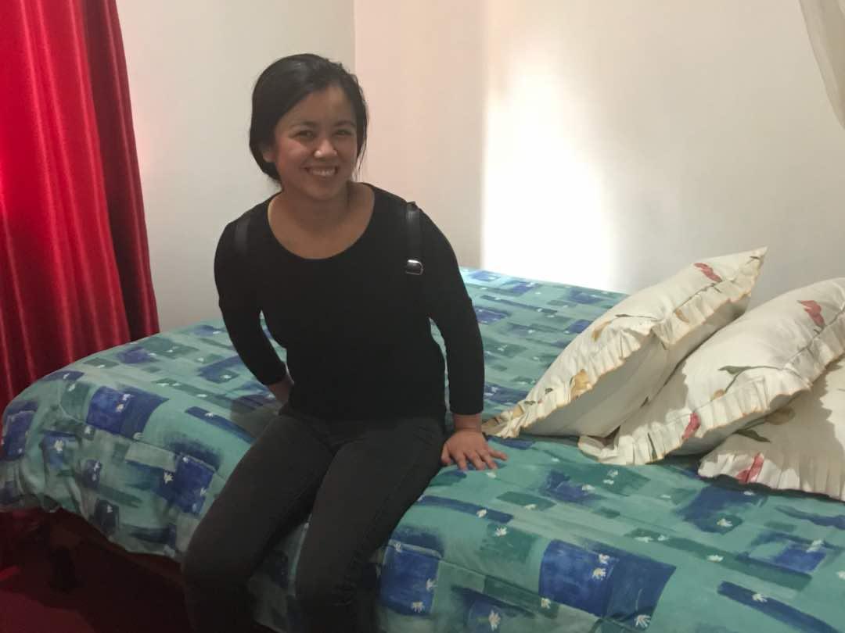
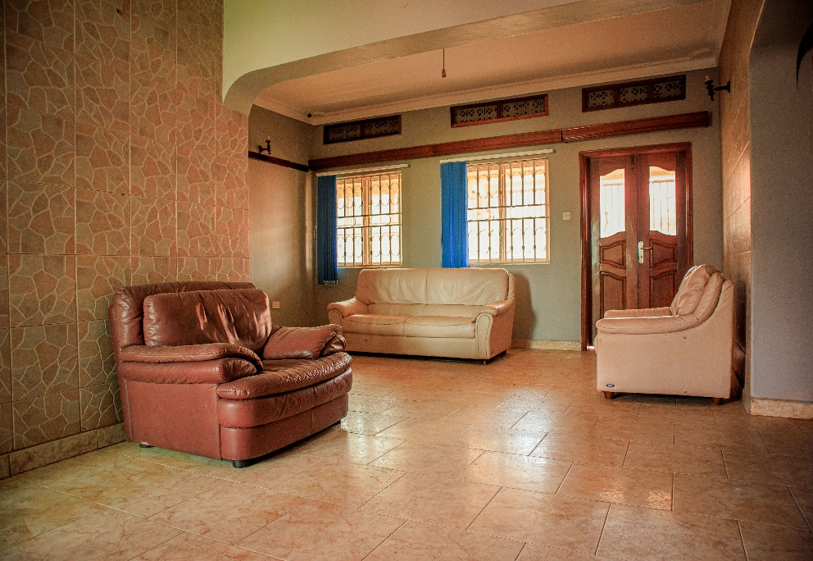
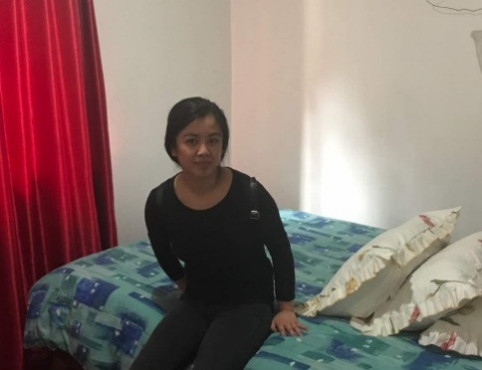
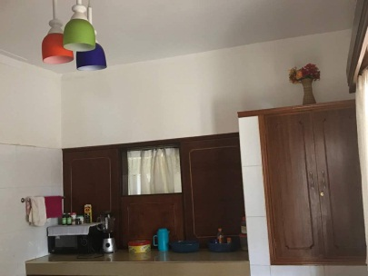
Our daily routine
Time | Activity | Notes
07.30 AM | Joint breakfast for residents | Served in the Dining Room. Please inform the housekeeping staff in the morning if you do not require meals on that day.
08.00 AM | An optional religious ‘Morning Glory’ | You don’t have to be Christian or even religious to attend – it’s a great time to sit down, reflect and hear about each other’s thoughts. Experience the ELOIM family feeling!
08.20 AM | Daily meeting (for Mondays only) | All staff and volunteers are expected to be present for a briefing about last week’s achievements and today’s plan.
08.45 AM | Start of working day
01:00 PM - 01:30 PM | Lunch | Lunch arrangements can be provided however need to agree in advance.
05.00 PM | End of working day
07.00 PM | Joint evening meal for all | Please inform the housekeeping staff in the evening if you do not require breakfast or tea (including wake up) in the morning.

Working in the ELOIM Office
- Office facilities – We will do our utmost to provide the facilities you need to carry out your work for ELOIM.
- We have office PCs with internet access though if you have a laptop then please consider bringing it with you. This will also help with the regular power cuts as you won’t be reliant on the PCs! We have wireless so it’s easy to connect to the internet.
- Limited printing & copying facilities are available so please use them sparingly.
- We have an office phone line for our operational activities. As we keep track of our costs – please log any calls in the appropriate place.
- You will also be able to communicate via Skype, Zoom, Teams, Etc if you need to.

http://en.wikipedia.org/wiki/Ugandan_English

General Dress Code
- Male Business Dress – Jacket with matching trousers, formal suit, formal shirt and tie.
- Female Business Dress – Blouse (matching jacket optional), matching skirt at least knee length or a matching pair of trousers.
- In ELOIM Office- Business Dress for men (Jacket & tie optional) and women.
- If meeting external contacts – Business Dress for men (including jacket and tie) and women. Identify yourself with an ELOIM badge or pin.
- Visiting Communities– As for external contacts or wear an ELOIM Polo T-Shirt.

Please now complete the final page and email it back to volunteer@eloiministries.org or info@eloiministries.org. This will be sent on to the appropriate person who will contact you prior to your visit to firm up your objectives.

If you have any feedback or would like to ask further questions; please contact any of the ELOIM Team Members.
We hope that you have found this Welcome Pack useful!

Enjoy your work as a Volunteer at Eternal Life Organization International Ministries and thank you again for your contribution to our work!

Visitor Information Sheet
Name

Contact Address

Tel. No

Email Address

Date arriving

Date departing

Will you be obtaining a visa in advance and need an authority letter?
Do you have any special meal requirements?

Is accommodation at ELOI House required?

What are the key objectives for your visit?

Have these been agreed with your ELOIM contact?
Will you be entering a rural community?
Any other comments

- Please return this form & the Disclaimer as soon as possible to volunteer@eloiministries.org or info@eloiministries.org as there is a lot of administration to do to make your travel and visit go as smoothly as possible!
Disclaimer

By submitting this application form I hereby declare that I understand and accept the following:
Please tick √ each box to confirm you understand & agree
I am required to have a general understanding of criminal justice issues and particularly the issues associated with working in a rural poverty stricken environment.
I am aware of and to consider the risks that come with working in a rural poverty stricken environment.
I am obliged to respect the local Authorities at all times.
I take responsibility for and indemnify ELOIM from responsibility for personal injury or death.
I am aware that no employer/employee relationship exists between me (and any other member of this research) and ELOIM.
I declare that I have a valid health and all - risk personal insurance policy for the full duration of the research/ volunteering and will provide evidence that I have a valid and comprehensive health and personal risk insurance to cover the duration of the research/ volunteer placement.
I am aware that I must present the above policy to our administrator before starting my relationship with ELOIM.
I am aware that all aspects of ELOIM’s activity must be approved by the ELOIM Management and any other relevant authority, in advance and for this I will provide any information, personal / institutional, required by the ELOIM mgt in order to assist in approving this research or volunteer activities.
I am aware that ELOIM has no responsibility for this provided information of any kind and I am aware that the ELOIM MGT can make use of this information as needed.
I am aware that ELOIM takes no responsibility for meeting any immigration requirements, these lie solely with the individual/s concerned.
I understand and accept ELOIM’s code of conduct and ethics.
I must adhere to ELOIM’s dress code.
I am aware that I am obliged to maintain the country (Uganda) laws.
I am aware that ELOIM is not a political organization and I am obliged not to be involved in any political activity of any kind in the country at any time while I am conducting this research or volunteer placement.
I am obliged not to write in any local newspaper or to be interviewed by any local media unless I have received a written approval from ELOIM Executive Director, and I am obliged to inform ELOIM Executive Director of any request for such interview by any media immediately.

Date
Signature
Name
Voluntary Position

